**High Level App Design Doc**

**In General**

*(Both DMs and Players will see these scenes)*

**Main Menu Scene** (subject to change)

The App should have a Main scene that has:

* Create a character
  + Runs through character creation process
  + Saves in a character folder
    - That folder needs to have a way to save individual characters to a campaign they have joined
* Join a game
  + Via a code/password sent by the DM
* Create a game
  + Create a campaign
* Access to the Rulebook

**Game Scene**

**Dice rolls**

The App needs to show the result of dice rolls. This will be shown by a dice rolling log.

There will be two parts to dice rolling log.

* Current roll
  + Needs to show the Success Tracker
    - Success Tracker should highlight the result of the dice roll.
* Previous rolls

A typical dice roll in this game needs:

* To always add 5 neutral dice.
* Total the values into the Current Roll log and show the result on the Success Tracker
* Add positive dice based on the attribute the player chooses
* Add a number of negative dice the DM chooses.

Edge case dice rolls:

* Some abilities can re roll dice
  + Individually and/or collectively
* Some abilities can swap one or more dice for another type of dice. This is called Upgrade.
* Similarly, some abilities can add or remove dice for an additional effect.
* Some roll may need to be referenced by abilities that remember some aspect of previous rolls.
* Plot Armour can used after any dice roll to add 4 successes to the roll.

**As a Player**

**Tabs**

The Character Sheet should be split into 4 tabs. Game, Character, Abilities & Equipment.

In addition, everything on the character needs to save throughout games.

**Game Tab**

This tab is the same as the Game Scene but describes what is specific to the players.

Should have everything that was described in Game Scene Dice rolls section no matter the Encounter mode the players are in.

This tab needs to change based on the type of Encounter the players are in.

* **No Encounter**
* Everything in the Game Scene entry applies here.
* Needs to have an Exert input
* **During Showdowns**
  + Needs to highlight leading player.
  + Needs to show who has had their turn.
  + Needs to show Leading player’s dice pool for their Exert roll
    - This needs to be able to be modified based on Assisting players result on their actions.
  + Should show assisting player’s options.
  + Turn Limit counter.
  + Success Tracker.
* **During Combats**
  + Turns on a hidden asset that has a list of participants of the Combat
    - This needs to show who has had their turn.
  + Turns on hidden assets that show Attack, Exert and Recover actions
  + Turns on hidden asset that shows the player’s Effort.
    - This needs to auto update on using abilities and players use the Recover action.
  + Turns on hidden asset that shows an Abilities button
    - When inputted brings a pop-up window that shows the player’s abilities
    - These abilities show each ability’s Cost, Level, Name and a Use button.
  + Needs to show CAP counter
    - Rolls made by player need to be modified automatically by their CAP.

**Character Tab**

Character tab info needs to be viewable when not playing.

* Attributes
  + Needs to auto fill when characters level up.
    - Should be unable to be modified otherwise.
* Character Name
  + Should be able to be modified during play and when not playing.
* Portrait
  + Upload an image into it.
  + Should be able to be modified during play and when not playing.
* Campaign Notes
  + Scrollable (subject to change)
  + Should be able to be modified during play and when not playing.
* Character Details
  + Should be able to be modified during play and when not playing.
* Persona
  + Should be able to be modified during play and when not playing.
* Traits (Subject to change)
  + Should be able to be modified when prompted by the DM.
  + Needs to account for temporary and permanent traits.
* Profession
  + Cannot be modified.
* Background
  + Cannot be modified.
* Experience
  + Needs to auto fill based on DM input.
    - Opt in functionality for DMs to allow their players mark their own experience
  + Should be interactable only when the player is at max Experience to allow player to level up.

**Abilities Tab**

* Abilities (Subject to change)
  + List of abilities needs to scrollable. (Potentially a search function as well)
  + Needs to interactable.
    - Should show a description, cost, level of ability and a use button for each level of the ability.
      * This should be in a separate pop-up window when interacted with.
  + Should also have functionality to view and use these abilities while in Combat and Showdowns.
  + Some abilities will need to reference when the player performs an action.
    - This should appear when performing that action.

**Equipment Tab**

* Lists for Weapons, Armour & Gear (Subject to change)
  + Equipment should have a toggle to automatically add the bonus of the equipment to their pool for the respective action or pool.
  + Needs a button that adds a piece of equipment from a list of available options.
    - For Weapons it should prompt them for Ranged or Melee.
    - Then they should choose between Basic, Moderate or Advanced.
    - Then they should be able choose from available Equipment Traits according to the type of Equipment.]
* Shields
  + Needs to have a Current Shields field & a Maximum Shields field.
  + Should auto update based on damage the GM assigns to the players and auto update based on healing abilities for player’s abilities.
    - Needs to have functionality for abilities that allow the player to take less damage.
  + Needs to be interactable in case:
    - The DM allows any of their player/s to change their own Shields using an opt in functions when creating the campaign.
    - The players want to change the attribute their using to calculate Shields.
* Health Tracker
  + Needs to highlight which tier the player is on.

**As a DM**

**Game Scene**

* Need to be able to initiate:
  + Combat functionality for the players
  + Showdown functionality for the player
  + Disable these when the Encounter is finished.
* DMs need to be able to view the results of dice rolls via the dice roll logs
* DMs should be able to view their player’s character sheets at any point.
* DMs should be able give their players equipment & money at any point.
* DMs need to be able target individual or multiple players for Resistance rolls.
* DMs need to be able to assign damage to players.
* DMs need to be able to assign damage to the enemies.
* DMs need to be able to assign negative dice to their players. This needs to able to be done in a few ways
  + Auto filled via monster difficult for Combat and Showdowns.
  + Should have functionality for DMs to assign additional negative dice from miscellaneous occurrences.
* Needs to track Fallout Event and Plot Twist trackers. Also needs notify the DM when it triggers
  + Opt in function during campaign creation to notify players when it triggers.

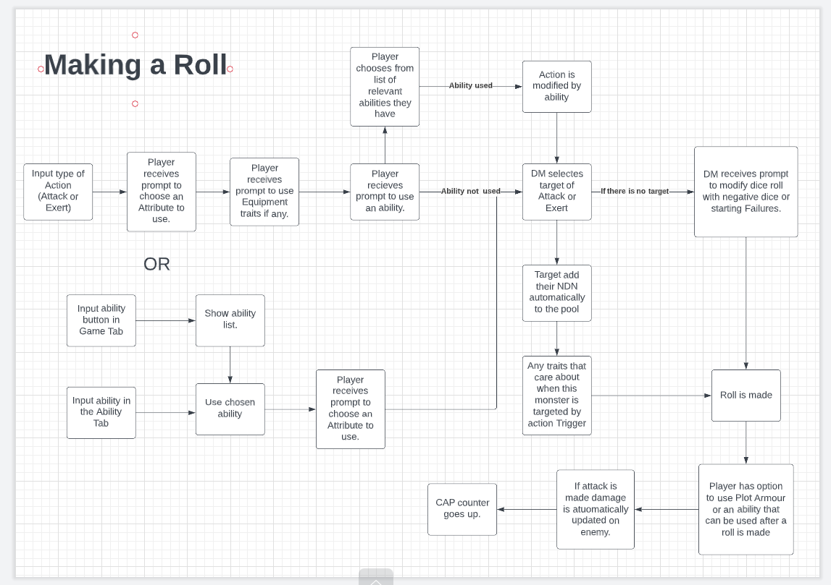

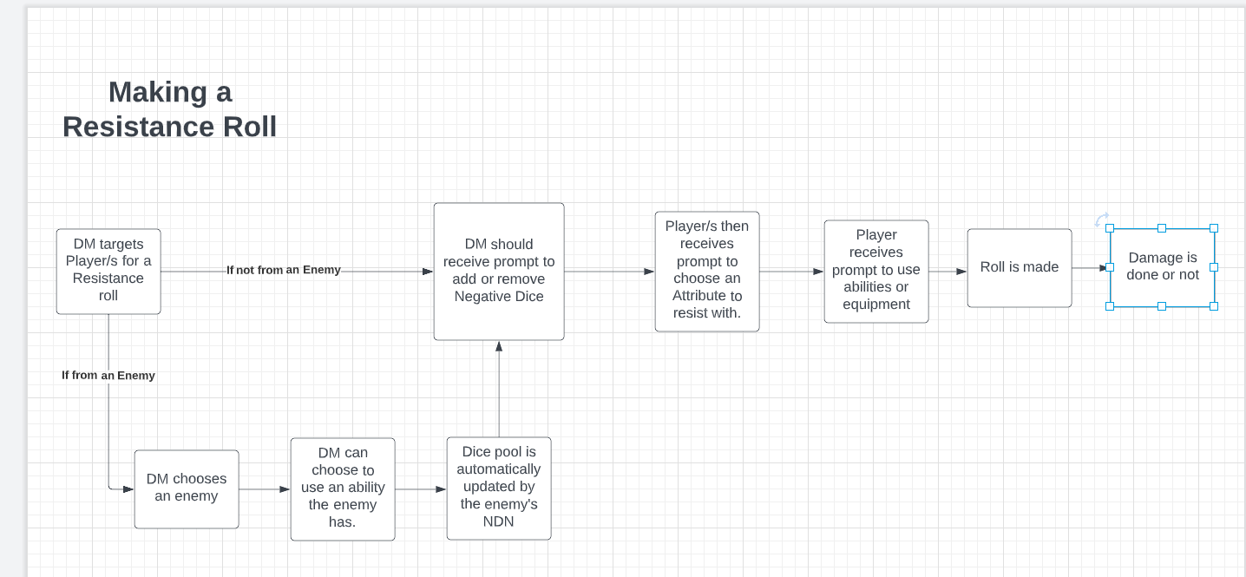

**Ideas for the future**

**DM Tools Section**

* Campaign notes section
* NPCs creator/gallery
* Monster creator/bestiary links
* Prompts for descriptions of dice results
* Random loot generator
* Random encounter generator
* Plot Twist / Fallout generator
* Prices for mundane crap
* Battle map
* Map tools
  + Highlighter
  + Range tool
  + Draw tool
* & Upload images